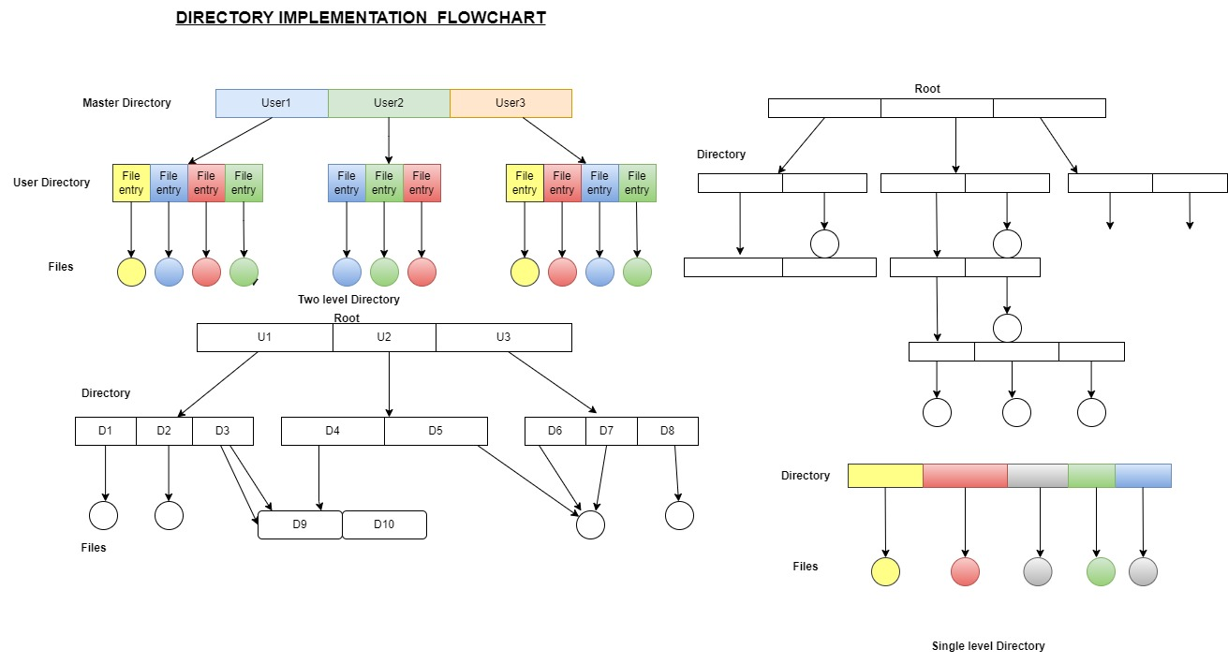

ALGORITHM

Step FIRST : create a list of directories that you want to maintain. You can do this by using the ls command to list the directories in the current directory, or by specifying a specific path to list the directories in that path.

Step 2 : create a loop to iterate through each directory in the list. You can use the for loop to do this.

Step 3 :WITHIN the loop, use the cd command to change to the current directory, and then use the mkdir command to create any missing directories.

Step 4 : After creating the missing directories, you can use the chmod command to set the appropriate permissions for each directory.

Step 5 : FINALLY, use the cd command to return to the original directory, and then repeat the process for the next directory in the list.